***WEST VIRGINIA BASKETBALL***

**Boys’ Individual Camp**

**June 21-24, 2020 202020**

**Ages 8-18**

*Camp is open to any and all entrants*

**Tuition**

Overnight Boarder……………….. $ 425.00

Day Camper ……………………... $ 350.00

*\*Must be 11 years of age or older to be an overnight camper*

**Day Participant**

Drop off time is 9:00 a.m. at the WVU Rec. Center. The camper will eat two meals (Lunch & Dinner) per day (excluding 1st day) and participate in all basketball camp sessions each day. Pick-up time is between 7:30-8:30 p.m.

**Registration: Sunday, June 21 at 5 p.m.**

**For More Camp Information Call:**

**(304) 293-2193**



**CAMP APPLICATION**

**CREDIT CARD AUTHORIZATION**

**(sorry, no debit cards accepted)**

Cardholder’s Name: _____________________________________

Billing Address: ________________________________________

Account Number: ______________________________________

Exp. Date: _________________ CW Code: __________________

Amount to be Charged: __________________________________

Authorized Signature: ___________________________________

Phone Number: ________________________________________

Register Online at wvucamps.com

Name: ______________________________________________________

Home Address: _______________________________________________

City: _____________________ State: ___________ Zip: ______________

Home Phone: ___________________ Age: __________ Grade: _________ Date of Birth: ____________ Check One: Overnight: Day Camper:

Email: _______________________________________________________

Parents’ Names: _______________________________________________

School: ______________________________________________________

Roommate Preference (only 2 to a room): ___________________________

**\*$100 Deposit required with application**

Make check or money order payable to: **West Virginia University**

Return form to: **Mountaineer Basketball Camp**

**PO Box 1877**

**Morgantown, WV 26507**





*Group Rates Available Upon Request*

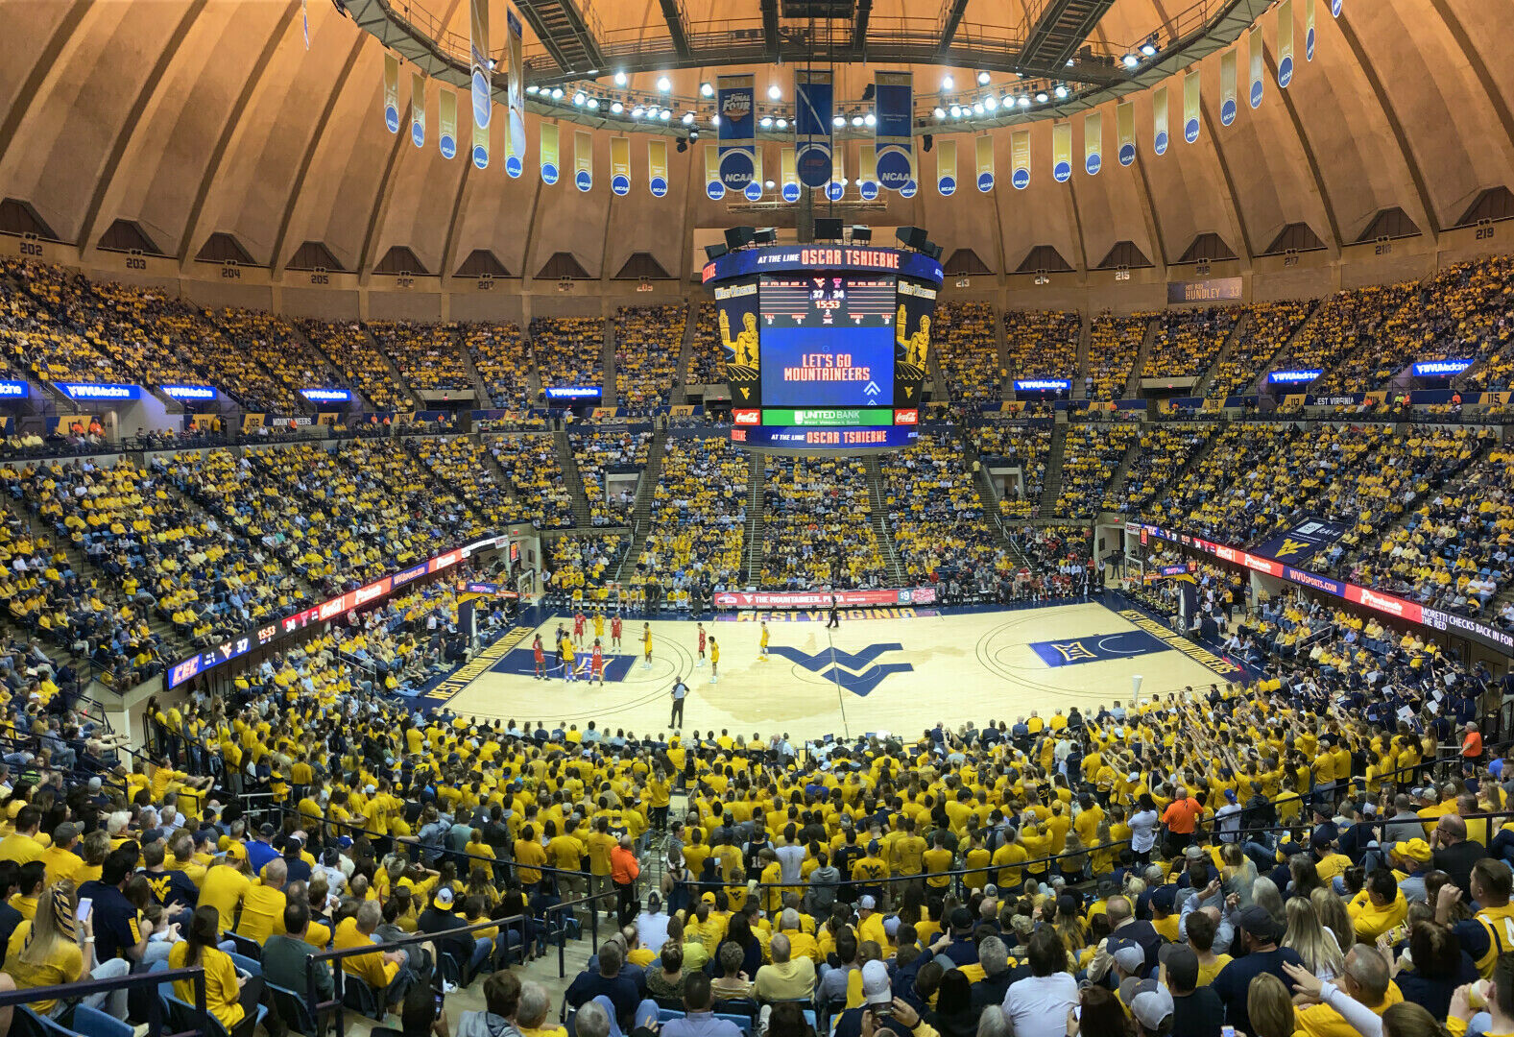

**Eligibility** All applicants must be between the ages of 8-18 for the individual camp. High School graduates are eligible to attend if they meet the age requirement. Camp is open to any and all entrants.

**Location** The camp is located on the Evansdale Campus of West Virginia University in Morgantown, W.Va. just 70 miles south of Pittsburgh

**Insurance** Campers must provide their own medical insurance. The camp has a professional medical trainer on duty at all times.

**Cancellation** There will be a $100.00 cancellation fee after May 15. All cancellations must be in writing. No cancellations will be accepted over the phone. All cancellations will be refunded after August 1. If a camper should have to leave camp early for medical reasons, the refund will amount to a prorate of room/board only.

**Discipline** Any serious violations of camp regulations will result in immediate dismissal from camp. If a camper is dismissed from camp, there will be no refund in any way.

**Tentative Daily Schedule**

7:45 a.m. ……………………………………..Wake-up

8:00 – 9:00 a.m. ……………………………..Breakfast

9:15 a.m. ……………………Attendance and Warm-up

9:30 a.m. ………………………………………Stations

10:45 a.m. ………………………………..Team Games

Noon …………………………………………..…Lunch

1:15 p.m. ……………………………...….Mini-Lecture

1:45 p.m. ……………………...….Games Fun Contests

2:45 p.m. ……………………………...…..Team Games

3:45 p.m. ……………………………...….Choice Period (Individual Work, Mountaineer Practice)

5:00 p.m. …………………………………….…..Dinner

6:15 p.m. …………………...….Attendance & Warm-up

6:30 p.m. …………………...……Team Games/Stations

7:30 p.m. ……...……Roll Call/Day Campers Dismissed

8:30 p.m. ……………………….……Down Time/Relax

10:00 p.m. ………………………………...…Lights Out

**Individual Camp Features**

* The camp will focus on your offensive development! Shooting the basketball and your 1-on-1 offensive moves will be emphasized every day
* Campers will be divided into three leagues and play approximately two games a day. Teams will be formed according to age and ability
* Daily lectures from our coaches will emphasize methods for individual improvement
* Accommodations – Campers will be housed two in a room in the modern, air-conditioned Evansdale Residential Complex. The ERC is a two-minute walk from camp headquarters, the WVU Student Recreation Center.
* Meals – All meals will be served in the ERC’s dining center. An all-you-can-eat meal plan starts with Monday breakfast and ends with Wednesday Lunch

I give the camp permission to use any camp-related photos of my son for camp publicity. I hereby authorize the directors of the Mountaineer Basketball Camp to act for me according to their best judgement in an emergency requiring medical attention. I hereby waive and release Mountaineer Basketball Camp. I know of no mental or physical problems which may affect my child’s ability to safely participate in this camp. I will be responsible for any medical and other changes in connection with his attendance at the Mountaineer Basketball Camp. I have read the rules and regulations of the camp and both the camper and I agree to abide them.

In consideration for permitting (me/my child) to participate in the Boys’ Basketball Camp/Clinic, and with the intention of binding (myself/me and my child) and (my/our respective) heirs, assigns and legal representatives, I hereby RELEASE AND WAIVE any and all rights and claims for damages which (I/I or my Child) may have against the Boys’ Basketball Camp/Clinic, the West Virginia University Department of Intercollegiate Athletics, West Virginia University and its Board of Governors, and their respective affiliates, directors, officers, employees, agents and representatives, for any and all property damage and personal injury of whatever kind suffered by (me/me or my child) in connection with (my/my child’s) participation in the Boys Basketball Camp/Clinic, except for those arising out of the willful misconduct, gross negligence or intentional torts of the above parties.

_______________________________ _____________________________________

Child Name & Signature Parent(s)/Guardian Name(s) & Signature(s) (if child is under 18 years of age)

THE CAMPER IS COVERED BY:

Insurance Company __________________________

Policy Number ______________________________

PLEASE TURN OVER AND FILL OUT REMAINDER OF FORM. RETURN ENTIRE FORM WITH YOUR PAYMENT

PO BOX 1877

Morgantown, WV 26507